**QUESTIONS**

**Tabel 1:**

1. 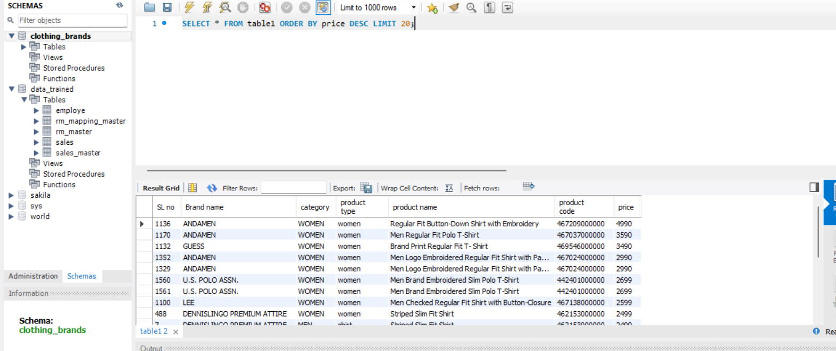Write a query to **Retrieve the Top 20  Most Expensive Products**
2. 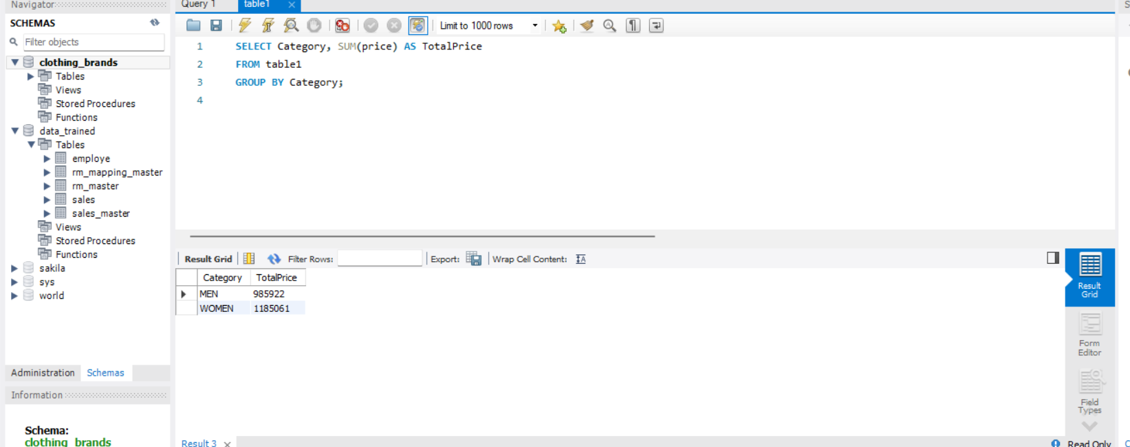   Write a query **Calculate the Total Price for Each Category**:
3. Write a query to **Retrieve Products with a Price Range** 2000 to 5000

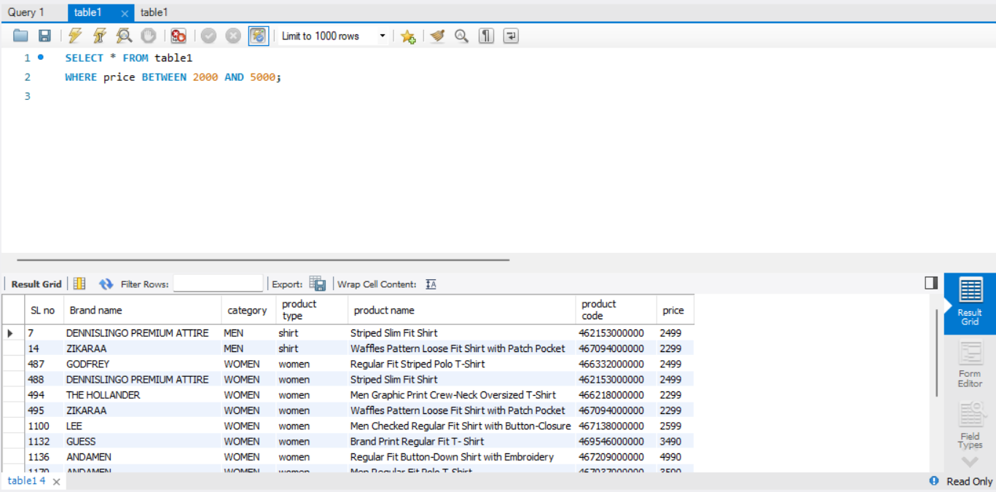

1. Write a query to **Calculate the Average Price for Each Brand .**

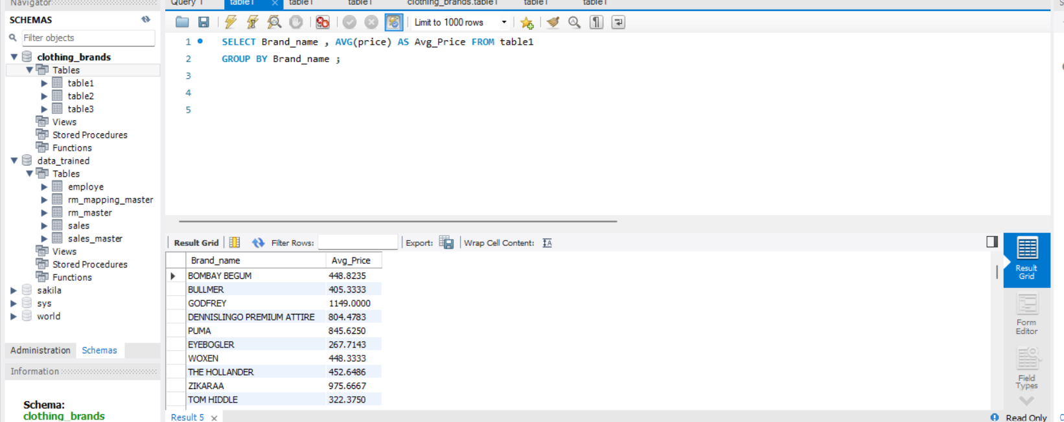

1. Write a query to **find Products with Unique Brand-Category Combination**

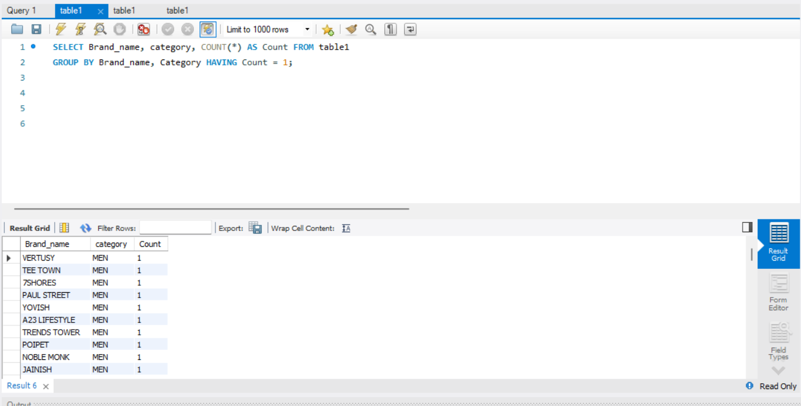

**Table2**

1. 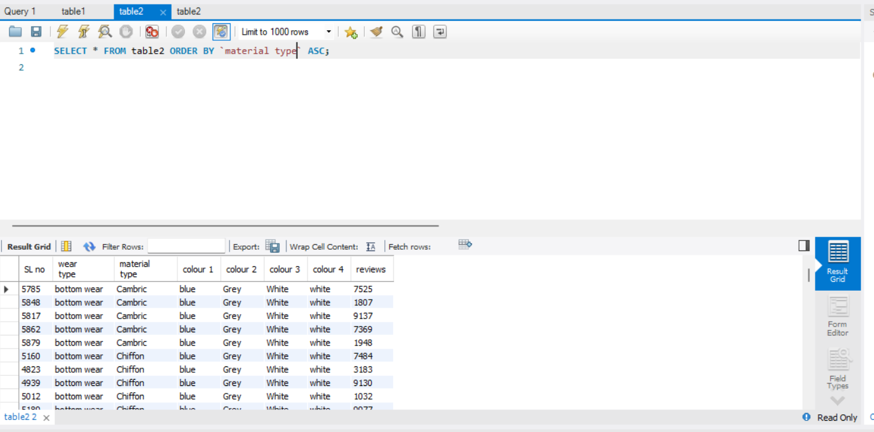Write a query **Order Rows by Material Type in Ascending Order .**

1. **Write a query to Calculate the Average Number of Reviews**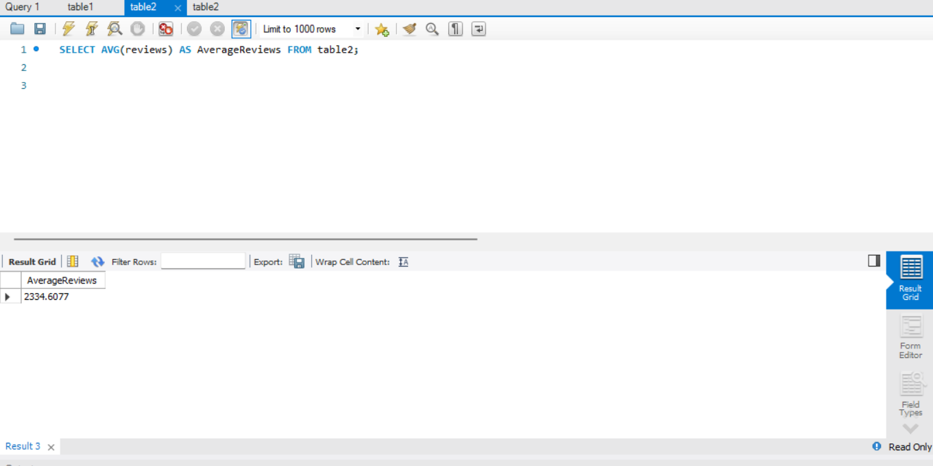
2. Write a query to **Calculate the Total Price for Each Material Type**.

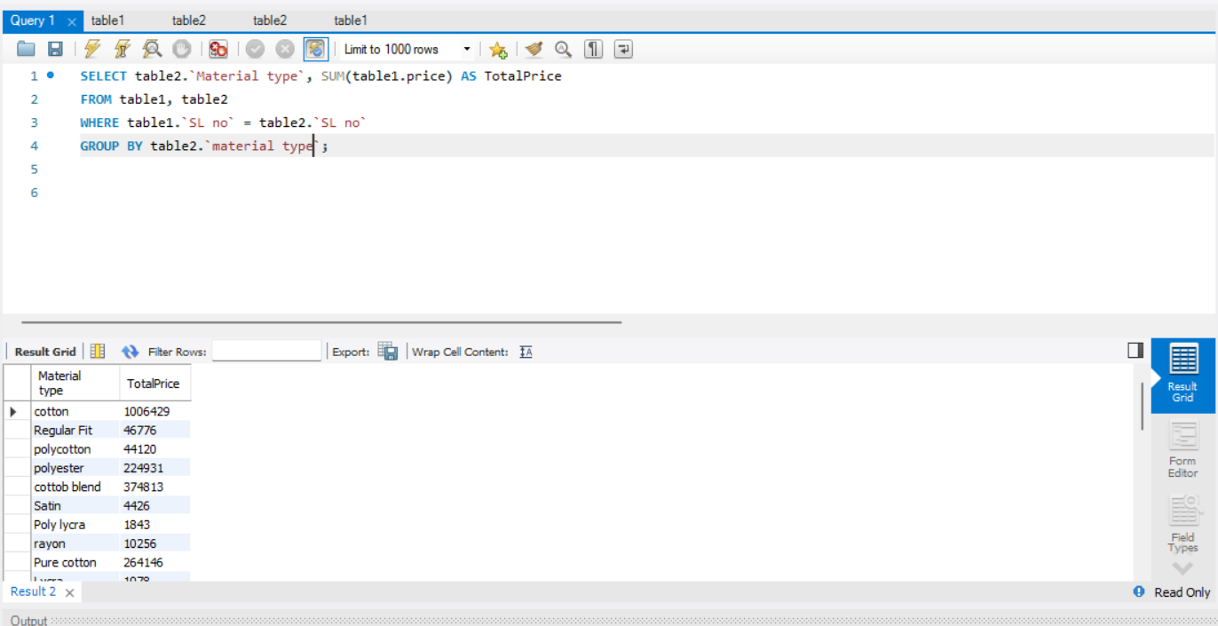



**Table 3 .csv**

1. 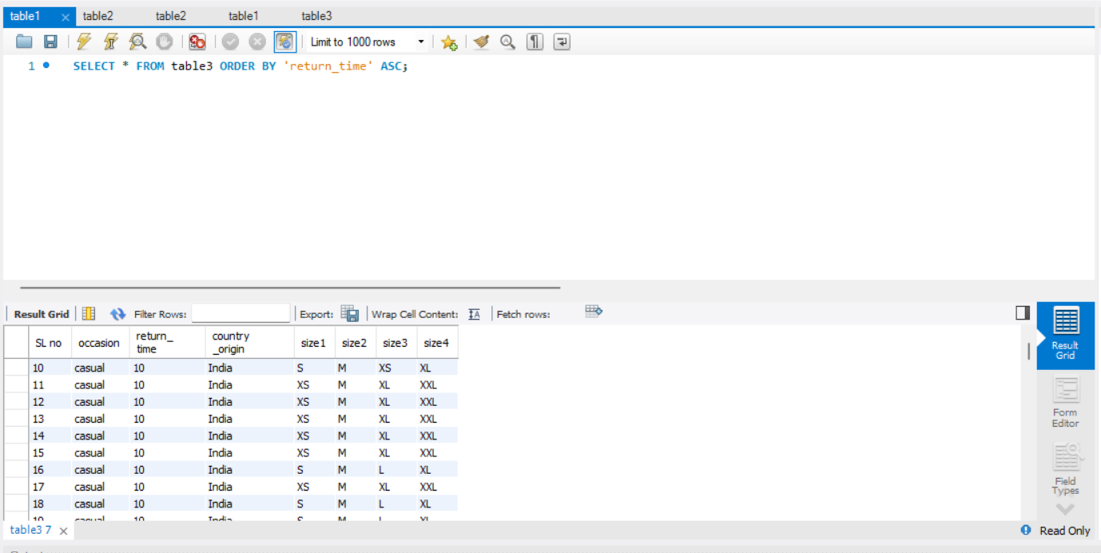Write a query to **Order Rows by Return Time in Ascending Order.**
2. 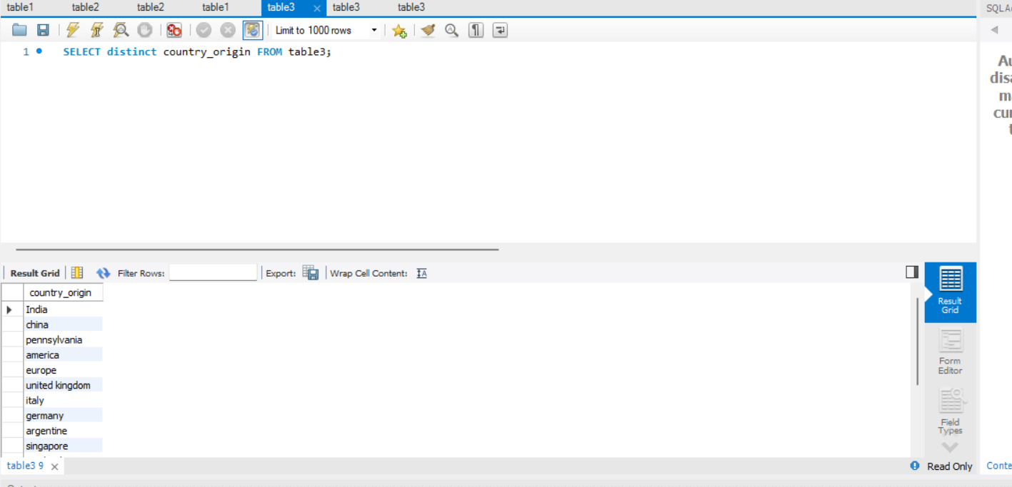Write a query to find distinct country of origin .
3. 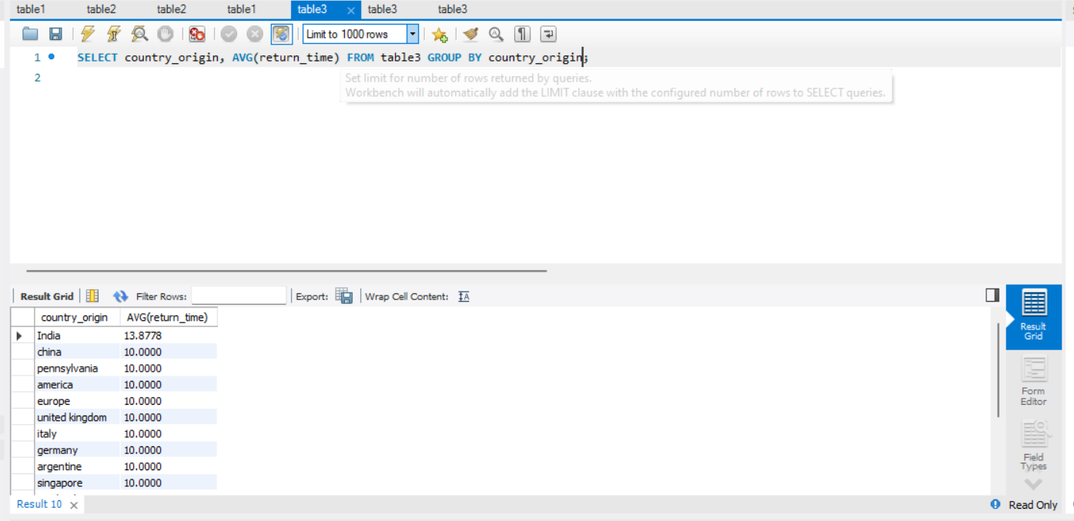Write a query to **Calculate the Average Return Time by Country of Origin**.
4. 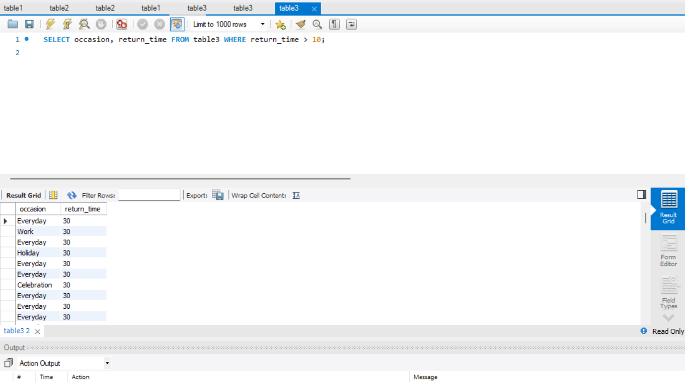Write a query to **Find Occasions with High Return Times.**

5 ) Write a query to **Retrieve Products with Multiple Sizes (Size1, Size2, Size3, Size4)**:

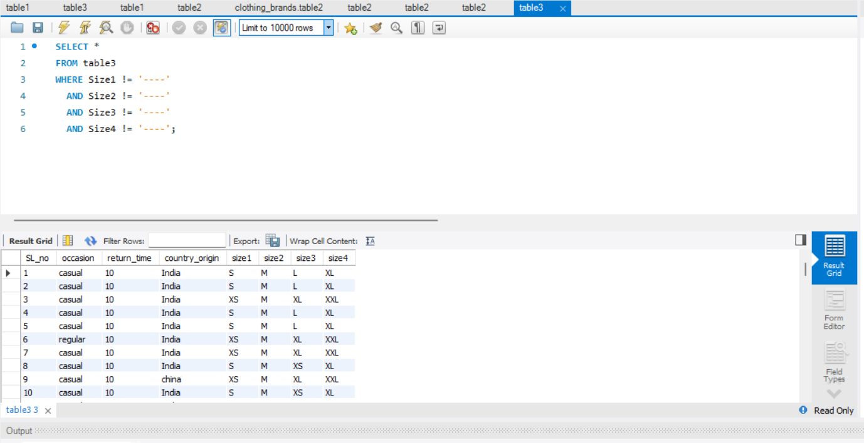

**JOIN QUERY  using table1,table2 and table3**

1. 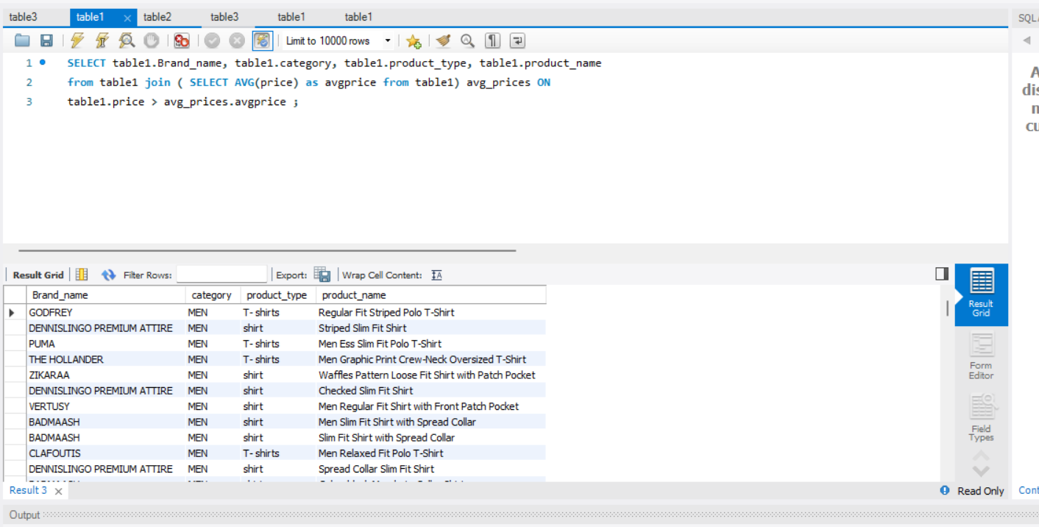Write a query  find Brandname, Category , Producttype ,ProductName  with a **listed price greater than the average listed price** in table 1.

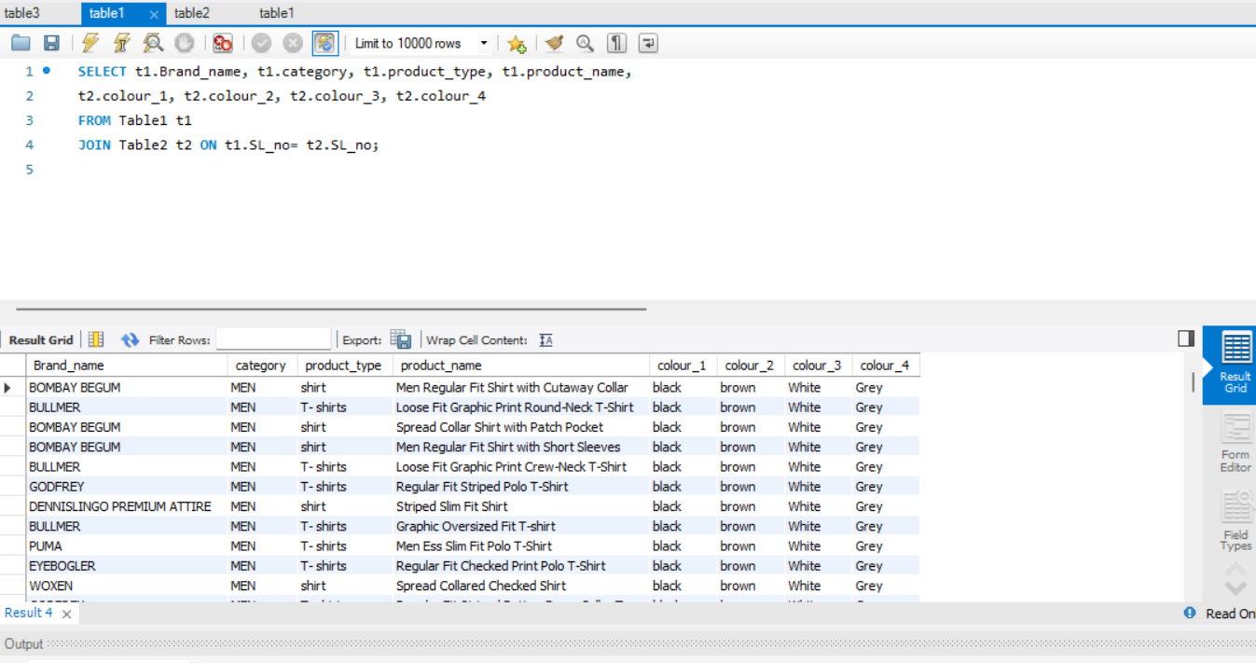2) Write a query to list all Brandname, Category , Producttype ,ProductName   along with their corresponding **color information** from Table2

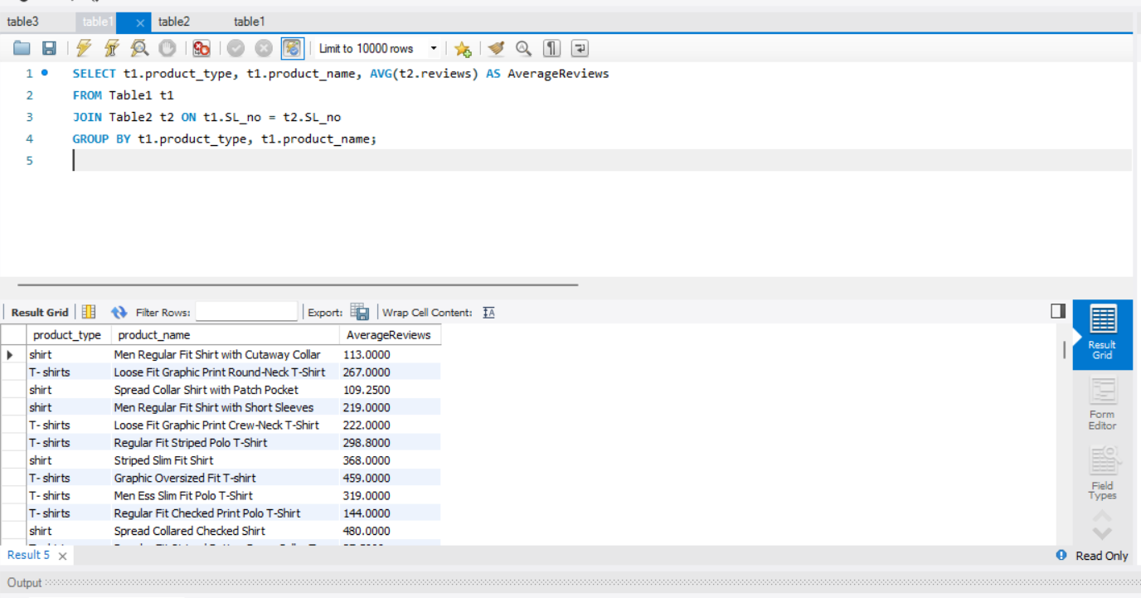3)      Write a query to find the **average reviews** for each Producttype ,ProductName   using table 1 and table 2

1. 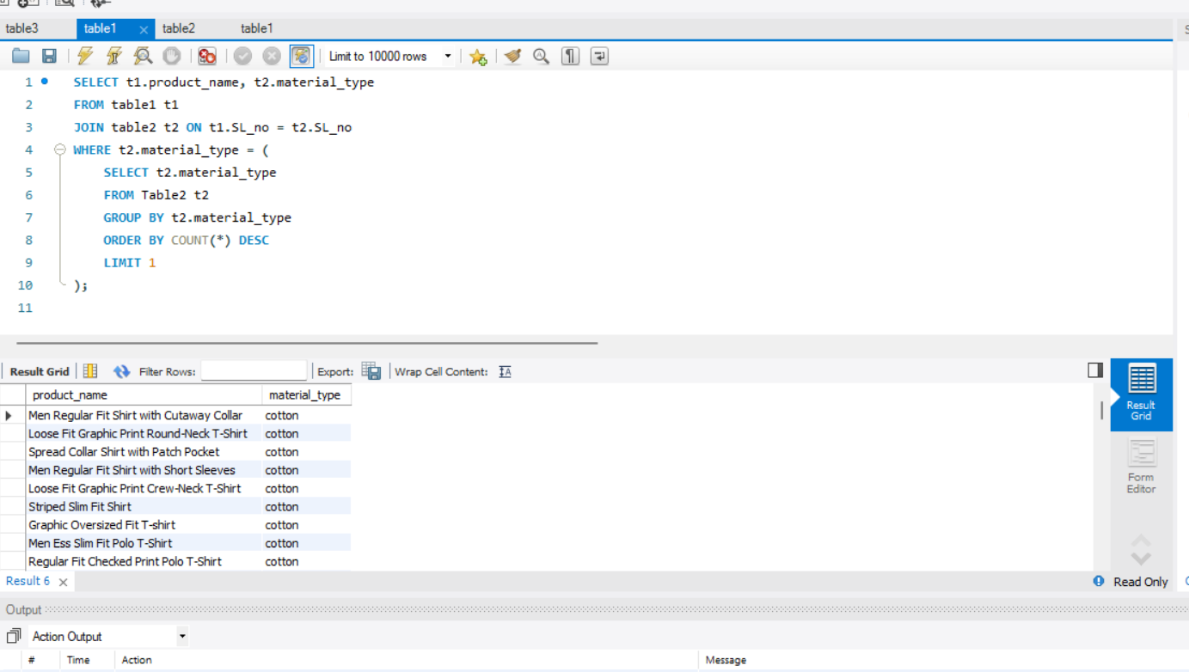Write a query  to find products with a Product name, **material type** that matches the **most common material type** in (use table1 and table 2)

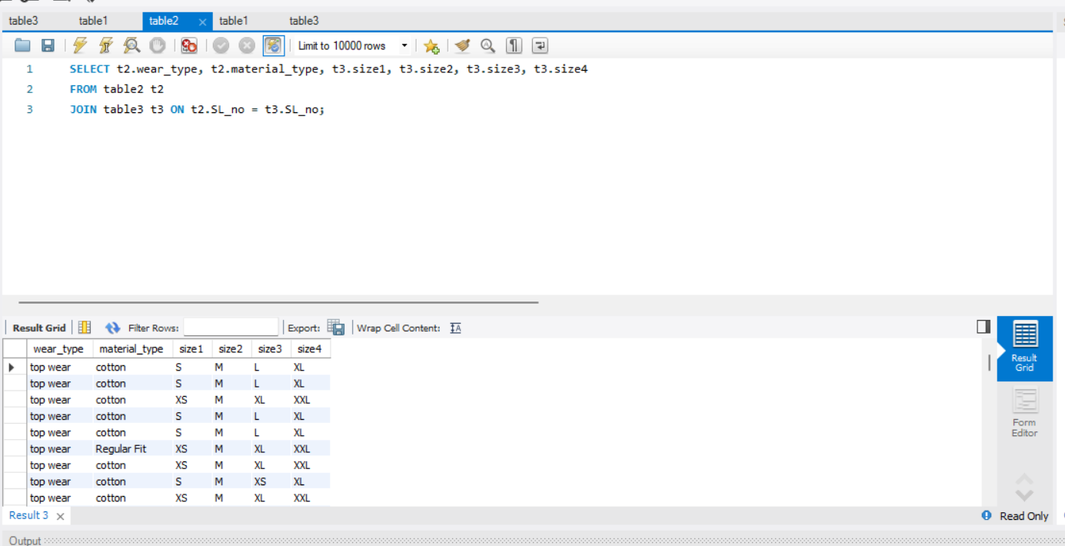5)  Write a query   to list all products  Weartype , Material type  along with their corresponding **sizes** from   (use table 2 and table 3)

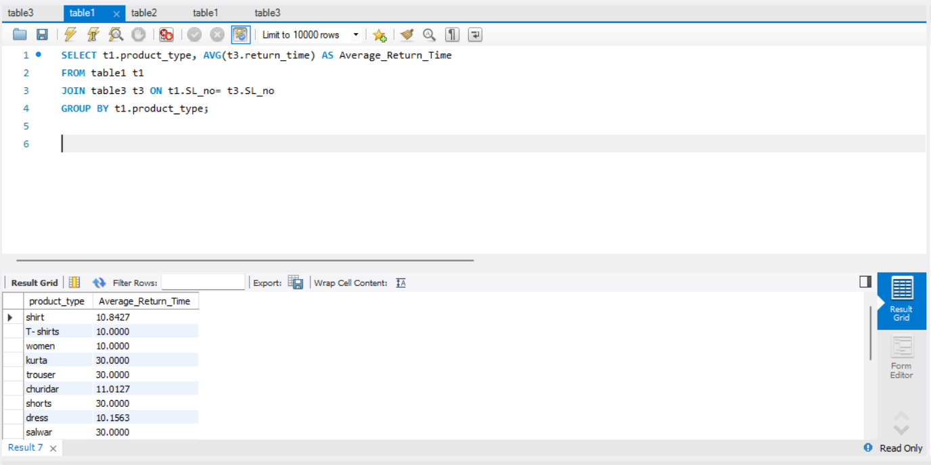   6) Write a query  to find the **average return time** for each product type (use table1 and table 3)

1. Write a query to find Country of origin, return time ,occasion of each product type .

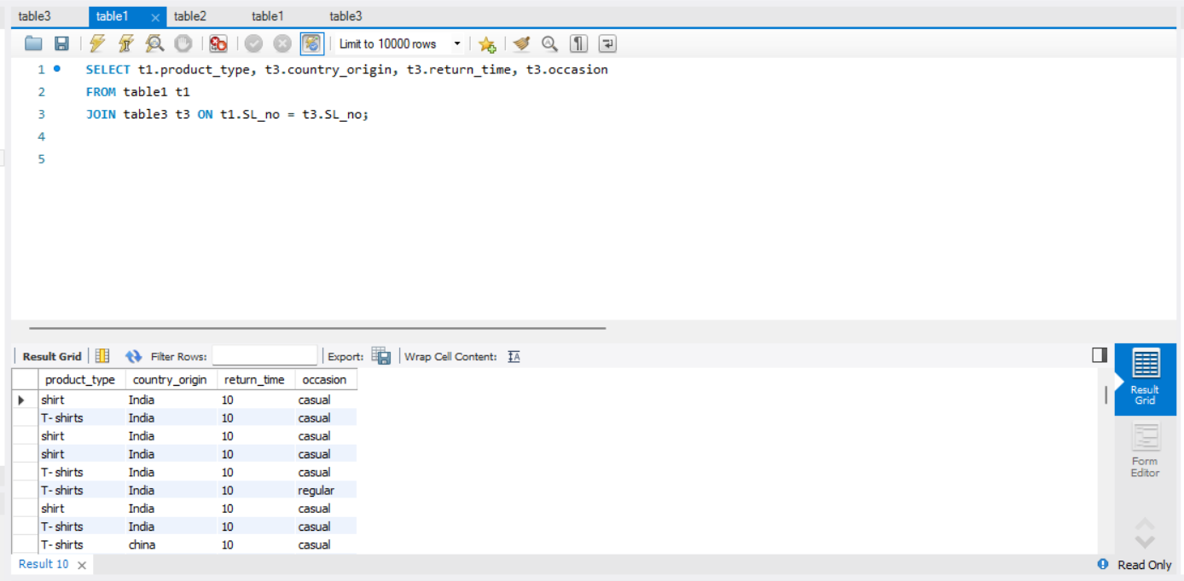(use table 1 and table 3)